# STOP MP3 for Level10, Unit1: Meeting

# Unit: Industrial English-Meeting

<https://ec.ef.com.cn/school/studyunit#school/86107f1f-935f-4e94-b936-8f4807c8a9c8/86107f1f-935f-4e94-b936-8f4807c8a9c8/0839215a-3334-46dd-8ddf-073863dcc440/325d2705-810a-4efc-b1e9-38210ef74468>

# Part1) Weekly meting

## Prestudy: Correspondence I_letter.docx

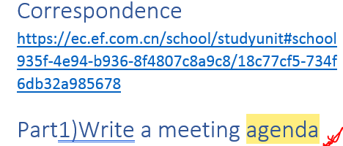

## Lexical resource

|  |  |
| --- | --- |
|  | adjourn   [ə'dʒɝn]  vi. 休会；延期；换地方  vt. 推迟；使…中止；使…延期  1.  [I,T] if a meeting, parliament, law court etc adjourns, or if the person in charge adjourns it, it stops for a short time  休（会）；休（庭）  •It was almost noon when the meeting adjourned. 休会时差不多已经是中午了。  [+ for/until]  •Congress has adjourned for the November elections. 国会因11月的大选而暂时休会。  •His trial was adjourned until May. 对他的审讯延期至5月份。  e.g. Meeting adjourned.  2.  adjourn to sth  to finish an activity and go somewhere – often used humorously  转移到别处；换地方〔常为幽默用法〕  •The rest of us adjourned to a nearby pub for some refreshments. 我们其他人转移阵地，去了附近酒吧吃点心。  DERIVATIVE 派生词  adjournment n [C,U]  •We sought an adjournment of the proceedings. 我们寻求暂缓诉讼。 |
| **People can also introduce new topics at the end of a meeting** | **Right then, any other business (A.O.B)?** OK, No. Well, it’s time for me to **recap** what has been discussed in today’s brainstorm meeting. |
| **扼要复述一下(重点)** | [ recap sth ]:   1. 1. V. [V-T/V-I](javascript:;)You can say that you are going to recap when you want to draw people's attention to the fact that you are going to repeat the main points of an explanation, argument, or description, as a summary of it. **扼要复述一下(重点) [recap/walk you through/ my main points]**   e.g. Let me just recap what’s been discussed in the meeting so far. 我来 **扼要复述一下** 已讨论过的内容吧。  e.g   **Can you recap the points** included in the proposal?   你能概括一下这个提议中包括的要点吗？  e.g. **Before I wra[p u]p the meeting, I'd like to** **summarize/recap/walk you through/go over my main points.** 在我“结束<会议/presentation>之前，我想 简明扼要的总结下 xxx”  E.G. **Before I wrap up**, l**et me recap/ walk you through the main points** in our today’s meeting: first, second, last but not least, finally   1. [N-SING](javascript:;)Recap is also a noun. 概要 e.g.   Each report starts with a **recap** of how we did versus our projections.  每一份报道都以一个概要开头，讲述和预期相比我们的表现如何。   e.g. IBM Security GCG 2017 **Recap** and 2018 Best Wishes to You |
| **赶紧结束（会议）** | [wrap up sth ]  e.g. The CEO is going to **wrap up this meeting**. e.g. Before I **wra[p u]p the meeting**, I'd like to **recap/walk you through/go over my main points**. 在我“结束<会议/presentation>之前，我想 **简明扼要的总结下 xxx”.** e.g. Let’s **wrap things up** and officially end the 7.7 release. |
| **会议主席chair等)让或同意(某人)发言; 给予sb.发言权** | **give the floor (会议主席chair等)让或同意(某人) 进行发言；演说;** **give the floor to****sb.给予sb.发言权 = the chair of the meeting grants sb. proper right to make a speech or statement in the meeting.**  e.g.  The meeting between the two heads of state, China and United States with the press media now begins. Now we would like to **give the floor first to the** Chinese President.  In a meeting, it's common for different speakers to present items from the agenda. When someone is invited to speak, we often say that they have **the floor** or **take the floor**. Three **idiomatic expressions地道的表达** are used to **give the floor to someone** in a meeting**(给予sb.发言权,让sb在会议上发言):**   * **[ Tracy, over to you. // Tracy, 你来发言吧]**  e.g. PHIL(the chair of the meeting): So, item one on the agenda: a new holiday request policy. Mark is going to **talk us through this/Mark is going to go over this.** because it's a very important change. All right, **Mark, over to you(给予sb.发言权,让sb在会议上发言)** . MARK: Yes, we've made a new online form to request time off. Employees will need to complete this two weeks in advance. You can find it on the website, and requests will go directly to your inbox. * Let me **turn things over to** our CFO Jack, who is responsible for reporting all company income next. “Jack, over to you”. * **[ Tracy, the floor is yours; the floor’s yours // Tracy, 你来发言吧]**  e.g. PHIL(the chair of the meeting): Thanks, Mark. **As you can see** (on the agenda), item two is a plan to improve communication between departments. **Linda, the floor is yours(给予sb.发言权,让sb在会议上发言).** LINDA: Yes, from now on we're asking that anytime you send out email marked 'very important' you cc me as well. That way, I can forward your email to any other managers who should know what's happening. * **[ Tracy, you have the floor; you have the floor on this]** * **[ Tracy, can you please take the floor; can you pls take the floor on sth // Tracy, 你来发言吧]** e.g. PHIL(the chair of the meeting): OK, then, the final item is planning for our annual dinner. **Kate, could you take the floor on this one(给予sb.发言权,让sb在会议上发言. //[美国英语](在辩论中、会议上)进行发言；演说; take the floor on sth: 就xxx话题进行发言；演说)?** Kate: Sure, xxx |
|  | Using the phrasal verb **talk through**, we can invite someone to present information and details.  E.g. *Tracy is going to****talk us through****this. = go over this* |
| 严格准时的; 精确的；确切的 | Punctual, punctually: acting or arriving exactly at the time appointed 严格准时的; pls be punctual for the meeting; be punctual for class. |
| Precise, accurate, exact.精确的；确切的; In mechanical field, the technical engineer must measure the device with punctual precision and accuracy by using highly sophisticated gauge [geɪdʒ] //sophisticated 1. 高精密的(仪器) e.g. a sophisticated gauge 2. She's a shrewd精明的 and sophisticated圆滑的 businesswoman. |
| **局限于空间上一点的或具有空间上点的性质的 Confined to or having the nature of a point in space.** |
|  | Metaphor V.S. simile e.g. In any company, weekly meetings are like the oil that powers the car (simile); the meeting minutes (action minutes) are the throttle油门 that can propel the car (metaphor). |
|  | to start a meeting:   * + **let’s kic[k o]ff. Let’s kick off with the last week’s “action minutes”.**   + **Let’s get started. Let’s get started with the MoM** last time. |
|  | Chair a meeting/Host a meeting |
|  | **cougar英 ['kuːɡə] V.S. leopard豹子**   * + **literal meaning): a large brown wild cat from the mountains of western North America and South America 美洲狮**   + **figurative meaning): sexy lady 熟女** |
|  | |  |  |  |  |  |  |  |  |  |  |  |  |  |  |  |  | | --- | --- | --- | --- | --- | --- | --- | --- | --- | --- | --- | --- | --- | --- | --- | --- | | When you work on a project, you may be asked to speak about progress, recent changes or unexpected problems.   |  |  |  | | --- | --- | --- | |  | **How's that coming along? 进展如何了吗 = How’s that progressing?** |  | |  |  |  |  |  |  |  | | --- | --- | --- | |  | **Can you tel[l u]s how that's progressing? 能告诉我们这个进展如何了吗(Did you make any headway = move forward)**  **Can you tell-us how that’s coming along?** |  | |  |  |  |  |  |  |  | | --- | --- | --- | |  | **What's the status on that? (make any headway?)**  **[Reponses to the update]** |  | | | |  | | --- | | You may be asked if you have finished (or almost finished) a project. |  |  |  |  | | --- | --- | --- | |  | *Have you completed that?* |  |  |  |  |  | | --- | --- | --- | |  | ***How close is that to completion? => It’s pretty close to completion.*** |  | | |

## Not mp3) Chair a meeting/Host a meet

**In any company, weekly meetings are like the oil that powers car (simile); the meeting minutes (action points) are the throttle油门 that can propel the car (metaphor, which means “make headway有进展，向前进”).**

|  |  |
| --- | --- |
| Kick off the meeting | So, **let’s kick off (with the last meeting’s action minute).** / **Let’s get started with the MoM** last time.  Dana, last week’s **action minutes** please.  The General Manager has been chairing/hosting the weekly meeting for years.  Firstly of all, he starts with the last week’s action minutes (action points to follow by a deadline) |
| Last week’s action minutes/action points | Dana:  Mark:  I hope to sign the contract this week.  General manager: Excellent news.  Dana:  Kelly: General manager: **Good. Keep it up**. And next (action point)?  Dana:  Eh: (he’s absent)  General manager: Umm, where’s Eh.?  The General Manager then moves on the weekly agenda. |
| This week’s meeting agenda | Weekly agenda:This week, I want you all to xxxxxx   * issue 1xxx * issue 2 xxx   …  Dana, today’s action minutes/points please. |
| Today’s action minutes/action points/MoM today: | * Tracy: do sth by <deadline> * Jill: do sth by<deadline> |
|  |  |

# Part2) Opening a meeting

When meetings start, the meeting leader welcomes everyone and says it's time to begin.

|  |
| --- |
|  |

|  |  |  |
| --- | --- | --- |
|  | *Thank you all for coming.* |  |
|  |  |  |

|  |  |  |
| --- | --- | --- |
|  | *Let's get started with sth = Let’s kick off with sth.*  e.g. Let’s get started with the MoM/action minutes last time  e.g. Let’s kick off with the last week’s action minutes. |  |

|  |
| --- |
| The meeting leader also checks that everything is ready. |

|  |  |  |
| --- | --- | --- |
|  | *Is everyone here?* |  |
|  |  |  |

|  |  |  |
| --- | --- | --- |
|  | *Did everyone get a copy of the agenda?* |  |

The meeting leader gives the main goal of the meeting and introduces the first topic of discussion.

|  |
| --- |
|  |

|  |  |  |
| --- | --- | --- |
|  | *The objective of this meeting is to            .* |  |
|  |  |  |

|  |  |  |
| --- | --- | --- |
|  | *Let's kick off with last week's minutes.* |  |

## 2nd row) Ask for action updates问工作进展 from the responsible(负责人) in a meeting

Asking for updates 问工作进展: Sue has just begun her design company’s regular weekly meeting.

|  |  |  |  |  |  |  |  |  |  |  |  |  |  |  |  |  |
| --- | --- | --- | --- | --- | --- | --- | --- | --- | --- | --- | --- | --- | --- | --- | --- | --- |
| |  | | --- | | When you work on a project, you may be asked to speak about progress, recent changes or unexpected problems. **进展如何了吗** |  |  |  |  | | --- | --- | --- | |  | **How's that coming along? 进展如何了吗 = How’s that progressing?** |  | |  |  |  |  |  |  |  | | --- | --- | --- | |  | **Can you tel[l u]s how that's progressing? 能告诉我们这个进展如何了吗(Did you make any headway = move forward)**  **Can you tell-us how that’s coming along?** |  | |  |  |  |  |  |  |  | | --- | --- | --- | |  | **What's the status on that? (make any headway?)**  **.. I’ve finished that task.**  **[Reponses to the update]** |  | |
| You may be asked if you have finished (or almost finished) a project.   |  | | --- | |  |  |  |  |  | | --- | --- | --- | |  | Have you completed that? |  |  |  |  |  | | --- | --- | --- | |  | **How close is that to completion?** |  | |
| You may be reminded when work is due.   |  | | --- | |  |  |  |  | | --- | --- | |  | The deadline is this Friday. | |

**Meeting Minutes**

Subject: Meeting  
Date: Week 24  
Participants/Attendees: Sue, Alison, Jack and Chris

| **Minute Item** | **Reason** | **Action** |
| --- | --- | --- |
| 1. Training presentations | Need training | Alison to make training presentation by week 25 |
| 2. Designs | Customer wants to see designs | Jack to finish designs by week 25 |
| 3. Content | Website needs new content | Chris to write new content by Friday, week 25 |

## Reponses to colleagues’ updates on their action points

When minutes are reviewed in a meeting, people respond with expressions showing how they feel. Some positive reactions are:

|  |
| --- |
|  |

|  |  |  |
| --- | --- | --- |
|  | *That's excellent news!* |  |
|  |  |  |

|  |  |  |
| --- | --- | --- |
|  | *Well done!* |  |
|  |  |  |

|  |  |  |
| --- | --- | --- |
|  | *Great work!* |  |
|  |  |  |

|  |  |  |
| --- | --- | --- |
|  | *Great job!* |  |

 This may be followed with encouragement to continue the good work:

|  |
| --- |
|  |

|  |  |  |
| --- | --- | --- |
|  | *Keep it up!* |  |

 Or, this can be followed by planning for future steps:

|  |
| --- |
|  |

|  |  |
| --- | --- |
|  | *How can we move forward on this?* |

Some expressions are more neutral. These finish or postpone discussion:

|  |
| --- |
|  |

|  |  |  |
| --- | --- | --- |
|  | *Thanks for the update.* |  |
|  |  |  |

|  |  |  |
| --- | --- | --- |
|  | *Maybe we can talk about that deadline later.* |  |

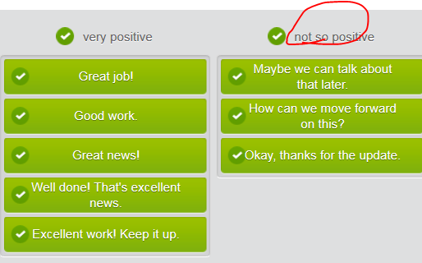

## Not mp3) 1st row

ANNE: Thanks for coming, everyone. And Lisa, I was very happy with your customer feedback report. **Great job** ! Now, **let's kick off with** an update from Jim. **What's the status on** the redesign project?

 JIM: Things are going very well. Actually, I think we can finish one week early.

 ANNE: That's **excellent news** , Jim. **Keep it up** ! And now item two. Lisa, your team is  rewriting our user guide. **How's that coming along/How’s that progressing? (Can you tell us how that’s coming along/How that’s progressing?)**

 LISA: We've had some problems because two employees have been sick. Unfortunately, we may need to change the deadline.

ANNE: **Thanks for the update** . I don't know if we can move the deadline; I'll need to check with other departments. **Maybe we can talk about that later.**

# Part3) Going through a meeting agenda

## Prestudy: Correspondence I_letter.docx



## Not mp3: 1st row)





|  |
| --- |
| OK, is everyone here? Good**, let’s get started/let’s kick off**. **The main objective of this** meeting is to **go over/review** some office rules.  **Does everyone have a copy of the agenda?** Good. **As you can see**, today’s agenda includes two items.   * Item one: office rules. We need to make sure that everyone is arriving to work on time/**punctually**. Management are unhappy that people are walking in at 9:30. * Item two: compliance with **the code of the business conduct** 遵守商业规范/准则 |
|  |

## Introduce a meeting agenda

**Starting from the agenda**

Before a meeting begins, you'll get an agenda which presents the topics to be discussed. We usually call topics on an agenda **items**.

“**Does everyone have a copy of the agenda?** Good. **As you can see**, today’s agenda includes xxx items:”

|  |
| --- |
|  |

|  |  |  |
| --- | --- | --- |
|  | ***The first item on the agenda is****our new documentation policy.* |  |
|  |  |  |

 You may hear the phrasal verb **go over**, which means 'review,' when a speaker states the meeting's purpose.

|  |
| --- |
|  |

|  |  |  |
| --- | --- | --- |
|  | ***The objective of this meeting****is to****go over*** *some new rules.* |  |

When the meeting has started, the speaker may ask you to look at something on the agenda by using the phrase **as you can see**.

|  |
| --- |
|  |

|  |  |
| --- | --- |
|  | ***As you can see****, the next item is a progress report on our new website.* |

|  |
| --- |
| Subject:xxx  Time: xxx  Location:  **Con-call number:**  Called by : Bob Franklin  Attendees :  -       Isabella Redwood [HR]       …  Topic : Next year's budget  Agenda :  **//As you can see, today’s agenda includes three items.**  -       Francis: to present the past year's budget report  -       Isabella: to talk about the new employment law  -       everyone: to share their department's budget plan  Goal : to decide on a rough budget allocation  **Action points to follow (the MoM after the meeting):**   * Sb.: to do by deadline * Sb: to do by deadline |

## 2nd row) Give the floor to sb. 给予sb.发言权,让sb在会议上发言

## Not mp3) Give the floor to sb. 给予sb.发言权,让sb在会议上发言

// **give the floor (会议主席chair等)让或同意(某人) 进行发言；演说;** **give the floor to****sb.给予sb.发言权 = the chair of the meeting grants sb. proper right to make a speech or statement in the meeting.**

e.g.  The meeting between the two heads of state, China and United States with the press media now begins. Now we would like to give the floor first to the Chinese President.

|  |
| --- |
| In a meeting, it's common for different speakers to present items from the agenda. When someone is invited to speak, we often say that they have **the floor** or **take the floor**. Three **idiomatic expressions地道的表达** are used to **give the floor to someone** in a meeting(**给予sb.发言权,让sb在会议上发言**):   * **[ Tracy, over to you. // Tracy, 你来发言吧]**  e.g. PHIL(the chair of the meeting): So, item one on the agenda: a new holiday request policy. Mark is going to **talk us through this/Mark is going to go over this.** because it's a very important change. All right, **Mark, over to you(给予sb.发言权,让sb在会议上发言)** . MARK: Yes, we've made a new online form to request time off. Employees will need to complete this two weeks in advance. You can find it on the website, and requests will go directly to your inbox. * **[ Tracy, the floor is yours; the floor’s yours // Tracy, 你来发言吧]**  e.g. PHIL(the chair of the meeting): Thanks, Mark. **As you can see** (on the agenda), item two is a plan to improve communication between departments. **Linda, the floor is yours(给予sb.发言权,让sb在会议上发言).** LINDA: Yes, from now on we're asking that anytime you send out email marked 'very important' you cc me as well. That way, I can forward your email to any other managers who should know what's happening. * **[ Tracy, you have the floor; you have the floor on this]** * **[ Tracy, can you please take the floor; can you pls take the floor on sth // Tracy, 你来发言吧]** e.g. PHIL(the chair of the meeting): OK, then, the final item is planning for our annual dinner. **Kate, could you take the floor on this one(给予sb.发言权,让sb在会议上发言. //[美国英语](在辩论中、会议上)进行发言；演说; take the floor on sth: 就xxx话题进行发言；演说)?** Kate: Sure, xxx |
| Using the phrasal verb **talk through**, we can invite someone to present information and details.   |  | | --- | |  |  |  |  |  | | --- | --- | --- | |  | *Jane is going to****talk us through****this.* |  | |

|  |
| --- |
|  |

|  |  |  |
| --- | --- | --- |
|  |  |  |

## Dialogue: Give the floor to sb. 给予sb.发言权,让sb在会议上发言

Phil's team are reviewing the agenda. Different people are going to present each item. Type the correct answers in the gaps.

PHIL(the chair of the meeting): So, item one: a new holiday request policy. Mark is going to **talk us through this/Mark is going to go over this.** because it's a very important change. All right, Mark, **over to you(给予sb.发言权,让sb在会议上发言)** .

MARK: Yes, we've made a new online form to request time off. Employees will need to complete this two weeks in advance. You can find it on the website, and requests will go directly to your inbox.

PHIL(the chair of the meeting): Thanks, Mark. **As you can see** (on the agenda), item two is a plan to improve communication between departments. Linda, **the floor is yours(给予sb.发言权,让sb在会议上发言).**

LINDA: Yes, from now on we're asking that anytime you send out email marked 'very important' you cc me as well. That way, I can forward your email to any other managers who should know what's happening.

PHIL(the chair of the meeting): OK, then, the final item is planning for our annual dinner. Kate, could you **take the floor on this one(给予sb.发言权,让sb在会议上发言)**?

## 3rd row) Close an item in the agenda and moving on

TOM: Recently, many employees have been arriving in the office at 9:30 and leaving at 5. This is not acceptable.

STEVE: **If nobody has anything to add, let’s close this item and move on to item tw**o. Charlie, over to you.

CHARLIE: OK, so, the dress code. Summer is coming, and I’d like to make sure everyone knows the correct kind of clothing to wear. Men can wear shirt and trousers, no tie necessary. Women can wear skirt, or trousers, and a shirt. However, no short skirts and no sandals, okay?

STEVE: **Right then, any other business (A.O.B) ?** No. Well, it’s time for me to **recap** what has been discussed in today’s meeting. **//recap sth: repeat the important points that have been said or discussed …**

**Closing discussion and moving on**

|  |  |
| --- | --- |
| It's important to make it clear when discussion of one item has finished and discussion of a new item is beginning. | **That's item one closed, on to item two.**  **Let's close this item and move on.** |
| Sometimes, a question may actually mean that it's time to start discussing the next item | **What's the next item on the agenda?** |
| When it seems like an item has been completely covered, the **speaker often offers a final chance to comment.** | **If nobody has anything to add, we can finish item one (and move on to the next)**. |
| People can also introduce new topics **at the end of a meeting** | **Right then, any other business (A.O.B)?**  No. Well, it’s time for me to **recap** what has been discussed in today’s meeting. **//recap sth: repeat the important points that have been said or discussed …** |

## Not mp3)



# Part4)Taking notes and writing MoM

## Not mp3) Run a meeting as a chair/host

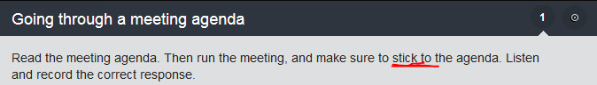

# =========================================

# Level10, Unit1: Meeting

<https://ec.ef.com.cn/school/studyunit#school/2505ece3-f653-4a2f-9edb-1fc969b4bae8/2505ece3-f653-4a2f-9edb-1fc969b4bae8/template_level;20000757/e9e4c214-be53-4f2a-a652-179d095a9cfb>

## Meeting type

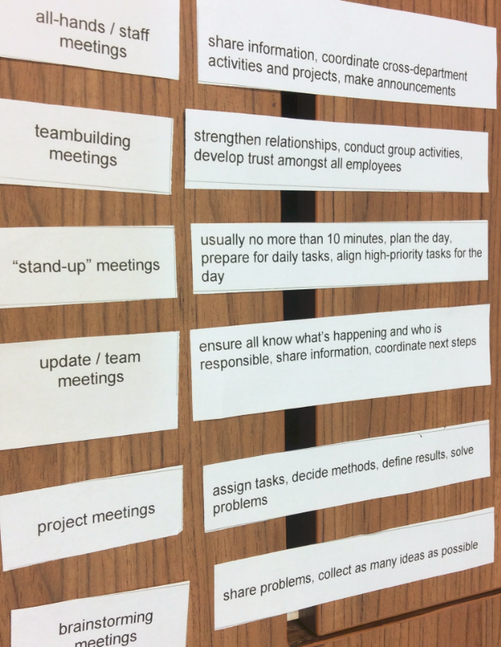

## **Lexical**

See the “UnitOverview_Level_10_Unit_1_meeting.pdf” in C:\Tracy\TW related\English\IETLS\oral topic\2 EF oral topics - Script based on Level\EF L17_FieldSpecific\Business English\Meetings

|  |
| --- |
| [daɪ'ɡres] digress, digression  V. [V-I](javascript:;)If you digress, you move away from the subject you are talking or writing about and talk or write about something different for a while; to talk or write about something that is not your main subject, deviating off your main point.〔说话或写作时〕偏离主题，转移话题 , 离题, 跑题了  E.g. Do you mind if I digress for a moment? 我说些题外话你不介意吧？  e.g. I've digressed a little to explain the situation so far, so let me now recap.  我刚才稍微离题说明了迄今的情况，现在让我重述一下要点  N) digression n /daɪ-ˋgrɛʃən ; daɪ'ɡreʃ ə n / [C,U]  e.g. After several long digressions he finally reached the interesting part of the story. 说了好几大段题外话之后，他终于讲到了故事的精彩部分。 |
| Sometimes a discussion will move off the subject like by interruption or by digression. Use these expressions to **return to the main topic after an interruption**:   * **Now, as I was saying (像我刚才在说的),** our competitive situation in Europe has changed. * **Now, where was I (“我刚才说到哪里了”)? Oh, yes** – the sales figures for last quarter. * **Getting back to my point, I think** a merger is not an option. * **OK, let’s return from digression /daɪ-ˋgrɛʃən/** 让我们回到正题(别跑题了) |
| **[stay behind: (e.g. meeting别人离开后)留下来，留在后面 ]**  e.g. OK. That’s it **for now**. **Thank you all for coming/I appreciate all of you being here**. Umm, Tracy, could you plz **stay behind**  (meeting后留一下)?  e.g. She deliberately **stayed behind** after work to go with me. 故意 留下来 等我一起走 |
| **[pull it off: 拉下来/谢幕；圆满完成, 成功完成]**  e.g. For the upcoming 7.7 release, it’s said that it’s a killer task with formidable challenges. But I’m confident that we’re smart enough and competent enough to **pull it off (成功完成)** |
| [wrap up sth ]  e.g. Before I **wra[p u]p the meeting**, I'd like to **recap/walk you through/go over all main points**. 在我“结束<会议/presentation>之前，我想 **简明扼要的总结下 xxx”.** e.g. Let’s **wrap things up** and officially end the 7.7 release. |
| [ in charge of sth = be responsible for sth ]  V.S. take the helm (of sth, like the dept, company):开始掌舵/开始执掌（公司大权） |
| outgoing /ˈaʊtˌɡəʊɪŋ/  1.[ADJ](javascript:;)Outgoing things such as planes, mail, and passengers are leaving or being sent somewhere. 往外去的  •  All outgoing flights were grounded.  所有的离港航班都停飞了。  2.[ADJ](javascript:;)Someone who is outgoing is very friendly and likes meeting and talking to people. 友好的; 喜欢交际的/健谈的 e.g.  She's very **outgoing, friendly, and talktive**. 她非常友好。  3.[ADJ](javascript:;)You use outgoing to describe a person in charge of something who is soon going to leave that position. 行将离职的  e.g. ...**the outgoing director** of the International Folk Festival.   …即将卸任的国际民俗节负责人。  E.g. **The outgoing manager** will serve us a big dinner as her farewell party. |
| [ fire sb/sack/dismiss sb = sb. be axed ]   * Sack sb:  If your employers sack you, they tell you that you can no longer work for them because you have done something that they did not like or because your work was not good enough. 开除sb.  e.g. If he hadn't been so good at the rest of his job, I probably would have **sacked him.**可能已经把他解雇了。 =>[N-SING](javascript:;)Sack is also a noun. 开除sb [ give sb. a sack; sb. get a sack ] * Dismiss sb. [V-T](javascript:;)When an employer dismisses an employee, the employer tells the employee that they are no longer needed to do the job that they have been doing. 解雇sb. e.g.•  ...the power to dismiss civil servants who refuse to work.   …解雇拒绝工作的公务员们的权力 * Sb be axed (used normally in passive voice) V) If someone's job/something such as a public service/a television programme is axed, it is ended suddenly and without discussion. (services，电视节目)被砍掉; sb.被(砍掉)解雇，被开除 e.g. Community projects are being axed by hard-pressed social services departments. 社区项目正遭到受困社会服务部门的削减 N)  **[被解雇，被开除 sb get the axe; 面临解雇: face the axe]** if someone gets the axe, they are **dismissed/sacked/fired/axed** from their job 被解雇，被开除  e.g.100 workers are facing the axe in a cost-cutting exercise. 100名工人面临解雇。 |
| ['duːəb(ə)l] doable= feasible/viable.  If something is doable, it is possible to do it.  可做的, 可行的 e.g. Is this project something that you think is doable?  你认为此方案可行吗？  V.S. **unworkable /ʌnˈwɜːkəbəl/**  **an unworkable plan/system/law** etc is not likely to be successful; If a plan, law, or system is unworkable, it cannot be successful. 不可行的 〔计划、制度、法律等〕; 不可行的/行不通的(计划、制度、法律等〕  e.g. There is the strong possibility that such merger will prove **unworkable**. 这种合作很有可能 行不通。  e.g. There are a number of issues that make the merger deal **unworkable**/impractical不能实行的.  e.g. The humanitarian system and human rights, like speech freedom, are likely to be **unworkable** in CHINA mainland. |

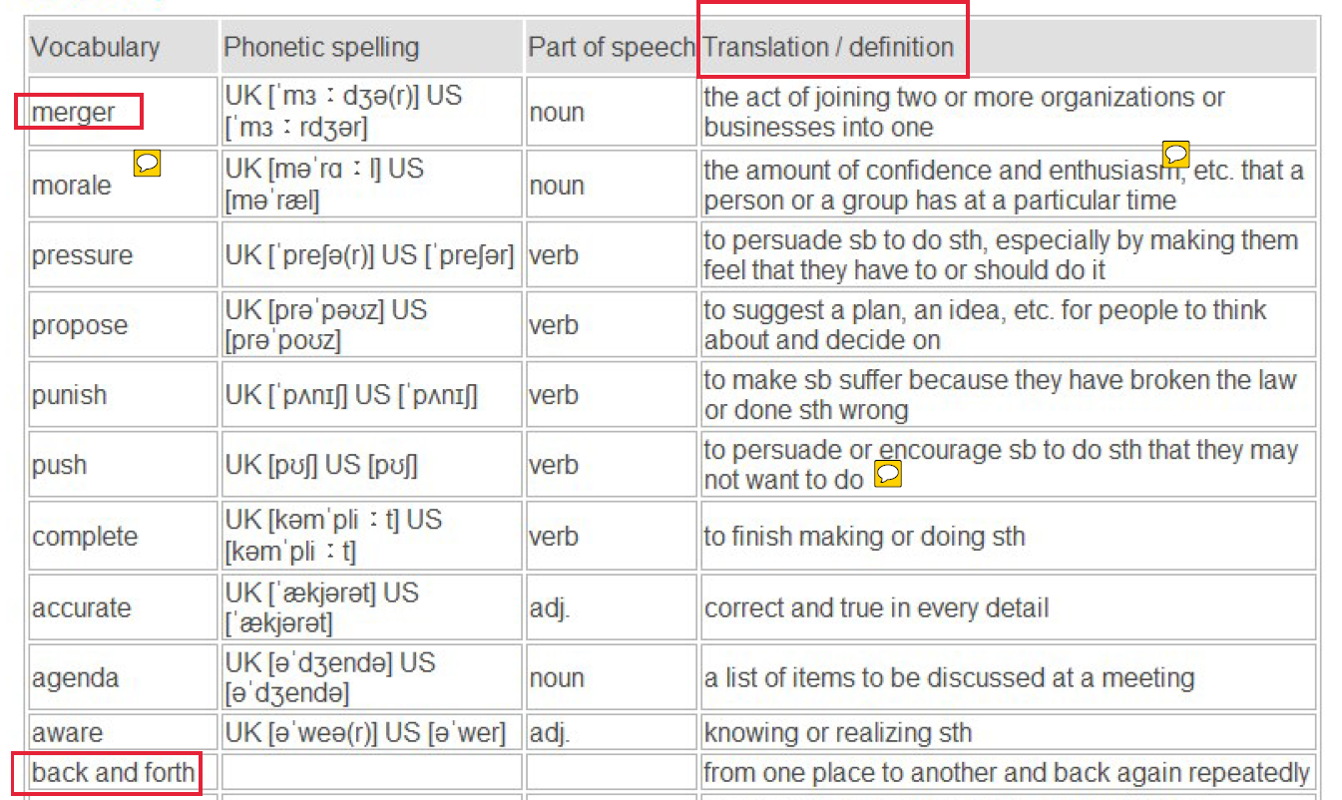

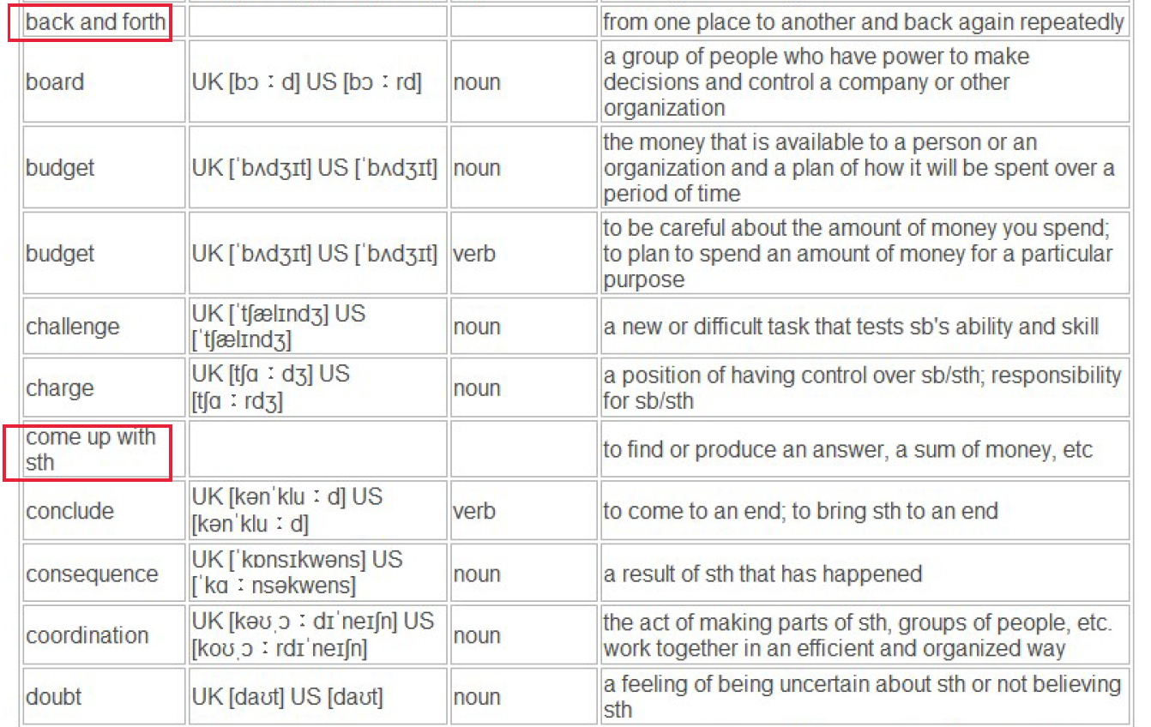

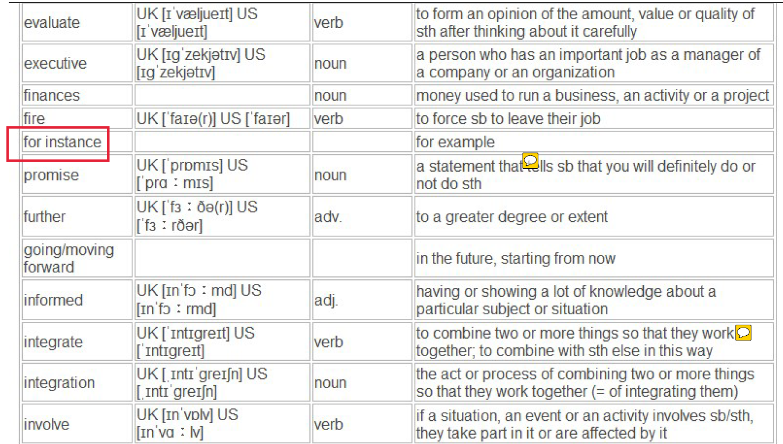

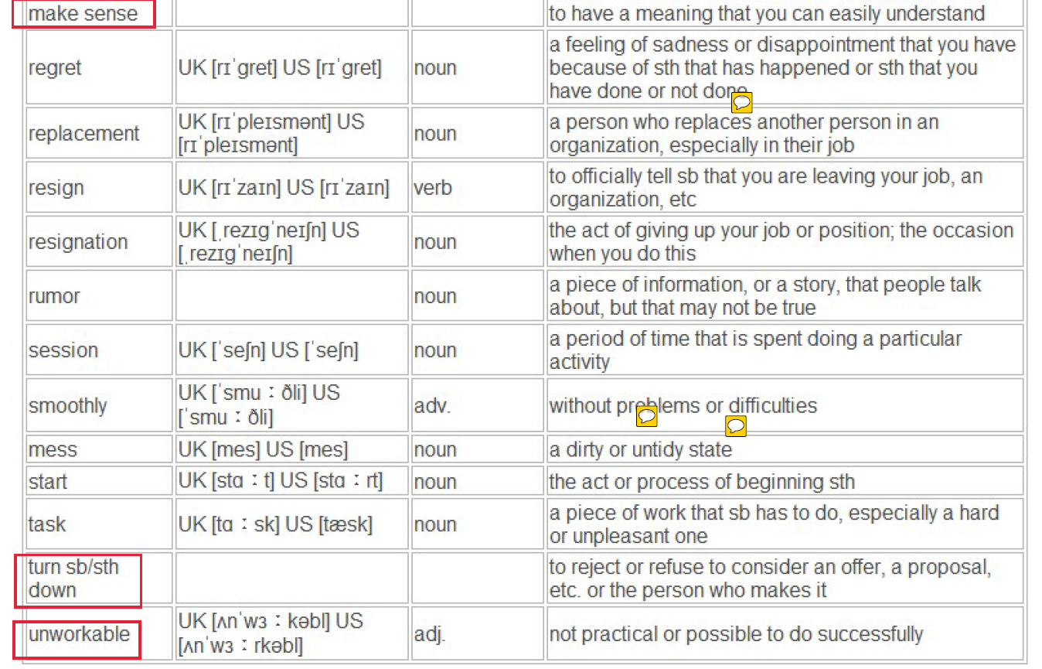

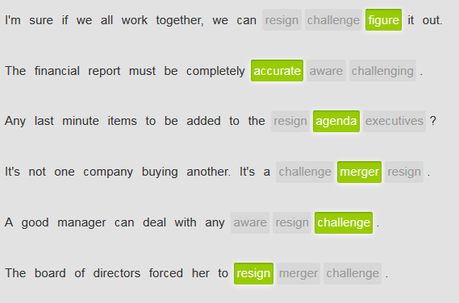

## Part 1)Start/open a meeting









No, I didn’t know that. No, **neither did** I.





//**outgoing**: You use outgoing to describe a person in charge of something will be soon going to leave that position. 行将离职的 [  ...the outgoing director; the outgoing manager]

…

 















 







## Start a meeting1

Host: **OK everyone, If I could have your attention please, let’s get started.**

Firstly, thank you all for coming today. **I know how busy you all are.**

**Well, do you all have the copy of the agenda? As you can see, we have *three* items to discuss today.** **The purpose of our meeting is** to talk about the relationship between us and the Sunset Computer since the merger. **We’re all here because** we do the most of business with them.

**Well, let’s start with the 1st item on the agenda. The 1st item** is the news of Sunset Computer. Are you all aware that the JPMorgan’s CEO has resigned?

Members: No, I don’t know that.

Members: **Me neither / Nor do I**

Host: OK, well, that means that our relationship with JPMorgan wasn’t working…The JPMorgan financial chief officer Maggie will be also leaving…

Member: that’s good news. I think it’s time to change

Host: **OK, let’s move on to the next item on the agenda.** I’m probably flying out to meet with JPMorgan’s executives next Mon. The CEOs might have more information about the merger late next Mon.

**The last item on the agenda** is our problems with Sunset. I’ve been hearing lots of complain from some people here, but I need more detailed information. So can you please help **glean** more information for me? [ glean information: to collect or learn sth slowly and patiently]

Member: For me, the primary problem is the communication between us and Sunset. We **lack of** that.

Host: Could you be more specific?

Member: Well, they’re very slowly answering our questions. For instance, yesterday, I reached out to their financial director, leaving him message and then I sent an email, and still no answer….

Member: The huge challenge for me is to **figure out** who is responsible for what specific thing.

Member: I have to say the IT engineers are incredible. They always provide me with information that I need very quickly, accurately, and efficiently.

🡺 Discuss proposals in the meeting 🡺

## **Start a meeting2**

**Excuse me, can I have your attention please…. Great, thank you, I think it’s time to get started.**

**First, does everyone have the copy of the agenda**? **As you can see, we have** lots of things to discuss.

Good. **Well, thank you all for coming here, and I know how busy you all are**. **The purpose of the meeting today** is to give you an update about the merger discussion that we’ve had with unset, one of our previous biggest competitors.

**We’re all here also because** I’d like to give you feedback about the proposal ideal. As you can see, **the 1st item on the agenda** is to update the financial effect of the proposed merger. OK, for that, let me **turn things over to** our CFO Jack who will give us her opinions about **the pros and cons of** the merger from finance point of view.

**“OK, Jack, over to you”**

**//pro[s and] cons：连读;** //**give the floor (会议主席chair等)让或同意(某人) 进行发言；演说;** **give the floor to****sb.给予sb.发言权 = the chair of the meeting grants sb. proper right to make a speech or statement in the meeting.**

## Part 2) Discuss proposals in a meeting







I’m not sure **I agree with that.**





Can you be more specific?















## Agreeing and disagreeing

|  |  |  |
| --- | --- | --- |
| ## There are many ways to agree or disagree with someone or something. Use these expressions for agreeing: | | |
|  |  |  |

|  |  |  |
| --- | --- | --- |
|  | *Yeah, that would be OK.* (mild agreement) |  |
|  |  |  |

|  |  |  |
| --- | --- | --- |
|  | *I think so, too.* (agreement) |  |
|  |  |  |

|  |  |  |
| --- | --- | --- |
|  | *I agree with you.* (agreement) |  |
|  |  |  |

|  |  |  |
| --- | --- | --- |
|  | ***We're on the same page.* (agreement)** | ) |
|  |  |  |

|  |  |  |
| --- | --- | --- |
|  | *I really like that idea.* (strong agreement) |  |
|  |  |  |

|  |  |  |
| --- | --- | --- |
|  | *You made a good point.*  *That sounds good to me.*  *I think those are excellent ideas.* (strong agreement) |  |

|  |  |  |
| --- | --- | --- |
| ## Use these expressions for disagreeing: | | |
|  |  |  |

|  |  |  |
| --- | --- | --- |
|  | *I'm not sure I agree with that.* (mild disagreement)  I see your point, but I have some different idea….  (mild disagreement) |  |
|  |  |  |

|  |  |  |
| --- | --- | --- |
|  | *I'm sorry, but I disagree.* (polite disagreement) |  |
|  |  |  |

|  |  |  |
| --- | --- | --- |
|  | *I'm not with you on that.* (disagreement) |  |
|  |  |  |

|  |  |  |
| --- | --- | --- |
|  | *I really disagree with you.* (strong disagreement) |  |
|  |  |  |

|  |  |  |
| --- | --- | --- |
|  | *I think that's a terrible idea.* (very strong disagreement) |  |

## Make proposals

|  |  |  |
| --- | --- | --- |
| There are many ways to make a proposal. Some are very direct, and others are more indirect. | | |
| **## Indirect or polite proposals** | | |
|  |  |  |

|  |  |  |
| --- | --- | --- |
|  | ***One way to solve the problem might be*** *to increase the training budget.* |  |
|  |  |  |

|  |  |  |
| --- | --- | --- |
|  | ***At least let's talk about*** *increasing the training budget.* |  |
|  |  |  |

|  |  |  |
| --- | --- | --- |
|  | ***How difficult would it be to*** *increase the training budget?* |  |
| **## Formal or direct proposals** | | |
|  |  |  |

|  |  |  |
| --- | --- | --- |
|  | ***I'd like to propose that*** *we increase the training budget.* |  |
|  |  |  |

|  |  |  |
| --- | --- | --- |
|  | ***I propose that*** *we increase the training budget.* |  |
|  |  |  |

|  |  |  |
| --- | --- | --- |
|  | ***Let's take that one step further and*** *increase the training budget.* |  |

## Nouns, verbs and adjectives for meetings

Here are some useful nouns for business meetings:

* There are five items on today's agenda.
* The final decision will be made by the xxCEO.
* Let me **turn things over to** our CFO Jack, who is responsible for reporting all company income next. “Jack, over to you”. //**give the floor (会议主席chair等)让或同意(某人) 进行发言；演说;** **give the floor to****sb.给予sb.发言权 = the chair of the meeting grants sb. proper right to make a speech or statement in the meeting.**
* *Our biggest* ***challenge*** *is to increase our market share.*

## Read an agenda

**Proposed merger with Intech Industries**

Agenda

* Jeff Grimes: Update from the CEO  
  Latest on the proposed merger – consequences for our company
* Sheila Jacobs: Update from the CFO  
  Financial report on proposed merger
* Bob Lewis: Update from the CTO  
  Technology strengths and weaknesses of both companies
* Open discussion of **pros and cons** of merger **//pro[s and] cons：连读**
* Jeff Grimes: Challenges we’ll face, next steps

## State problems

When stating problems, it is important to be clear and concise. Use the words **problem** or **challenge** to clearly identify the problem.

|  |
| --- |
|  |

* **The primary problem is** a difference in management style.
* **The biggest challenge we face is** growing competition.
* The core problem is a huge lack of financial support. Anyway, **everything boils down to money.归根结底是xxx**

|  |  |  |
| --- | --- | --- |
| **Clarifying and giving examples** | | |
| If a problem is not clear, ask for clarification. | | |
|  |  |  |
|  |  |

|  |  |  |
| --- | --- | --- |
|  | A: *The biggest problem is their CFO.* |  |
| B:***Could you be more specific?*** |  |
| **Use details and examples to be specific.** | | |
|  |  |  |

|  |  |  |
| --- | --- | --- |
|  | ***For instance/For example,*** *they don't return our phone calls.* |  |
|  |  |  |

|  |  |  |
| --- | --- | --- |
|  | ***The best example I can give is*** *our decreasing market share.* |  |

## **Meeting**

Host: Hello everyone, If I can have your attention please, let’s get started. Well, I call this meeting in order to update you that we’ve cancelled the **merger** negotiation with our competitor.

There are a number of issues that make the merger deal **unworkable/impractical不能实行的**.

Member: **Could you be more specific?**

Host: Certainly, **the primary issue is that two companies didn’t fit very well.** We have lots of different on the management style. **Furthermore**, the key issue is we found that the merger does not improve our business.

Member: So, we’re gonna find another company for us to merge with?

Host: No, **the big challenge** that we face is that we have to enhance our competitiveness and deal with the decreasing market share. With lots of flexibilities and creativities, that would be **a huge challenge** for all of us, and I’m confident that we’re smart enough and competent enough to **pull it off (拉下来/谢幕；圆满完成, 成功完成)**

## Part 3) Conclude a meeting

//Use **the future continuous** tense with **will**, or **be going to** with the verb **be** and a present participle, to **talk about a continuous action** that will be happening in the future.



// Use **the simple future** with **will** and its negative form **won't** to volunteer to do something, to make a promise or to make a prediction



// Use **the future continuous** tense with **will**, or **be going to** with the verb **be** and a present participle['pɑːtɪsɪp(ə)l]分词, to **talk about a continuous action** that will be happening in the future.



|  |
| --- |
| KAREN: You wanted to see me, Mr. Barnes?  MR. BARNES: Yes, Karen. Please have a seat.  KAREN: Is everything OK?  MR. BARNES: Yes, yes. It's just that the **coordination** between our team here in London and our office in Shanghai isn't going very **smoothly**.  KAREN: That's too bad. To be honest, I have heard some **rumors** .  MR. BARNES: Yeah, I think everyone has, including the CEO and the rest of the New York office. Anyway, I'll be doing some back and forth between here and Shanghai. I'm sorry I have to get you **involved** , but when I'm out of the office, you'll **be in charge** . I'd like for us to talk at least once a day so you can keep me informed. I'm sure I'll have some other tasks for you as well.  KAREN: No problem. Anything I can do to help.  MR. BARNES: Thanks, Karen. |

## Grammar-future tenses (simple future V.S. future continuous)

|  |
| --- |
| * Use **the simple future** with **will** and its negative form **won't** to volunteer to do something, to make a promise or to make a prediction. |

|  |  |  |
| --- | --- | --- |
|  | *e.g. I promise I* ***won't*** *spread any rumors.* |  |
|  |  |  |

|  |  |  |
| --- | --- | --- |
|  | *e.g. I'm sure that team coordination* ***will*** *improve.* | . |
|  |  |  |
| * Use the simple future with **be going to** to talk about plans, or to make a prediction. | | |
|  |  |  |

|  |  |  |
| --- | --- | --- |
|  | *e.g.He* ***is going to*** *travel to Mexico City next week.* |  |
|  |  |  |

|  |  |  |  |  |  |  |
| --- | --- | --- | --- | --- | --- | --- |
|  | *e.g. I believe we'****re going to*** *have a merger.* | | | |  | |
|  | | |  | | |
| * Use **the future continuous** tense with **will**, or **be going to** with the verb **be** and a present **participle['pɑːtɪsɪp(ə)l]分词**, to **talk about a continuous action** that will be happening in the future.   *e.g****. I'll be doing*** *some back and forth between here and Mexico.*  *e.g****. She's going to be running*** *the office while he's away.*   * Use the **future perfect** with **will** or **be going to**, the verb **have** + a past **participle['pɑːtɪsɪp(ə)l] 分词** to talk about actions **that should be completed at a certain point in the future**. | | | | | | |
|  | |  | |  | | |

|  |  |  |
| --- | --- | --- |
|  |  |  |
|  |  |  |

|  |  |  |
| --- | --- | --- |
|  |  |  |

|  |  |  |
| --- | --- | --- |
|  | *e.g .The meeting* ***will have concluded*** *by the time you return.* |  |
|  |  |  |

|  |  |  |
| --- | --- | --- |
|  | *e.g. We* ***won't have finished*** *the project by next week.*  e.g. *By the end of the meeting, I hope we* *will have come up with some creative ways to improve communication between our teams.* |  |

Good afternoon, everyone. First, **I'm going** to give you all an agenda so we're all on the same page. We **will** spend approximately 20 minutes on each item. I hope that you **will** all give us some suggestions and recommendations in the discussion. **I'm going** to ask you for ideas if I have to. This is a group effort. **By the end of the meeting**, I hope we **will have come up with** some creative ways to improve communication between our teams. Please speak freely. This will be a brainstorming session. There are no bad ideas. Jack **is going to** be writing down all of our ideas so we **won't** lose anything. OK, let's get started.

## Start a new point/topic in a meeting

When starting a new point in a discussion, use the following expression. Expressions like **let me see** can give you a buffer moment to gather your thoughts.

|  |
| --- |
| * **Let me see. The next point of discussion is** challenges in the coming year. * **Moving on, let's discuss** the plan to expand overseas. * **Oh, and one more thing:** we need to discuss a change in employee insurance. * **The next item on the agenda is** an update from our CFO. |

## Return to the main topic after an interruption

Sometimes a discussion will move off the subject like by interruption or by digression**/daɪ-ˋgrɛʃən/** . Use these expressions to **return to the main topic after an interruption**:

//〔说话或写作时〕偏离主题，转移话题 , 离题, 跑题了If you **digress**, you move away from the subject you are talking or writing about and talk or write about something different for a while; to talk or write about something that is not your main subject, deviating off your main point.

|  |
| --- |
| * **Now, as I was saying (像我刚才在说的),** our competitive situation in Europe has changed. * **Now, where was I (“我刚才说到哪里了”)? Oh, yes** – the sales figures for last quarter. * **Getting back to my point,** I think a merger is not an option. * **OK, let’s return from digression /daɪ-ˋgrɛʃən/** 让我们回到正题(别跑题了) |

## Conclude/Summary the meeting

See Part 4 Summarize a meeting (MoM)

## Close a meeting

To bring a meeting to a close, people often first indicate that the meeting is ending. Then they discuss the next tasks that everyone should complete. These are called **next steps**. Finally, the person leading the meeting will thank everyone for coming.

* Use these expressions to state that **a meeting is coming to an end**:
  + *OK, I know we're all busy, so* ***let's conclude this meeting quickly.***
  + *I think that's all about it.* ***Let's wrap things up / end it quickly.***
  + ***Unless anyone has anything else****, I think we're ready to talk about* ***next steps****.*
* Use these expressions to talk about next steps. When people volunteer for future tasks, they use the word **will:**
  + ***I'll follow up on*** *<finding a better location for the office>.*
  + ***Moving forward,*** *we will need to learn more about our competition.*
  + ***As a next step, let's*** *all think about ways to improve communication.*
* Use these expressions to discuss confidentiality:
  + Uh, one more thing: **This meeting is confidential. Nothing leaves this room**,OK?
  + I just want to say again/emphasize that this discussion is confidential. **Nothing leaves this room.**
  + **Nothing (we've discussed here) leaves this room.**
* Use these expressions to conclude the meeting and thank the participants:
  + OK, that's it for now. **Thank you all for coming. Nice day.**
  + I think we're finished here. Thanks very much to you all.
  + This has been a very **productive meeting**. **I appreciate all of you being here**.
* Use these expressions to ask sb. not to leave the meeting.

**[stay behind: (别人离开后)留下来，留在后面 ]**  e.g. OK. That’s it for now. Thank you all for coming/I appreciate all of you being here. Umm, Tracy, could you plz stay behind?

## Practice

You are concluding a meeting about your company's budget for next year. One topic was a possible hiring freeze. Talk about **next steps**, discuss **confidentiality**, and **then** **Close a meeting**.

## Part 4) Summarize a meeting (MoM)

* Recap the main points
* Go through the main points
* In summary, to sum up, in conclusion, xxx

## Issues, decisions and changes





….



 //turn down: reject

 

None😊

Hi, Sarah.

Well, it was a very interesting meeting. There were a lot of different opinions.

The COO suggested that the board move quickly to accept the government's offer. The CFO disagreed. He proposed that they wait until the financial results from the next quarter were available before making any decision. The CEO agreed that they shouldn't move too quickly, but she also decided they should schedule another meeting with the government for next week.

I'll let you know what happens.

Jim

## Express regret

Use these expressions to ask about regrets.

|  |  |
| --- | --- |
| Remember that the word **regret** can be a noun or a verb.  N) have regrets **about** sth/doing sth  V) regret doing sth | **Do you have any regrets about** leaving the company?  **Do you regret** turning down/rejecting the job?  **She regrets that she didn't** accept the position. |
| 我真希望我当时做了xxx（其实没有做, 表示后悔了) I wish **I’d done** sth (**had done)**  => which means actually I didn’t do that thing | **e.g. I wish I had accepted** the job offered by Alibaba. (which implies that I turned down the offer from Ali and now I have regrets about my decision) |
| 我当时应该做xxx (其实没有做, 表示后悔了)  * Should **have done** sth  => which means actually didn’t do that thing表示后悔了  * should **have done** sth if **I had (I’d) done** sth | **e.g. We should have hired** the other candidate rather than Travis. (which implies that we regret hiring Travis, but should choose to hire the other candidate)  e.g. I should **have obtained** SH Hukou If **I’d (had) gained** a master in Canada. |
| **做都已经做了，就接受现实吧 What's done is done.** | Use the expression What's done is done. to accept the reality of the current situation. |

## Summarize a meeting

Listen to the CEO who is going to **wrap up this meeting** Then write your coworker a meeting summary. Write what the decisions were and what Judy proposed at the end.

Type in the input box. Write 50-75 words.

